* Regression is a statistical technique used to understand the relationship between variables.
* Linear Regression is a fundamental and widely used supervised machine learning algorithm. This technique is used for predictive analysis, making it suitable for predicting continuous or real-valued variables such as sales, salary, age, and product prices.
* **For example,** predicting house prices based on features like size and location is a common application of linear regression in machine learning.

->It can be expressed mathematically as:

**$ y = mx + b $**

* **Example of Linear Regression in Machine Learning:**
* Scenario: Predicting a student's exam score based on the number of hours studied.
  + Independent Variable (Input): Hours studied.
  + Dependent Variable (Output): Exam score.
* **Application:** By collecting data on hours studied and corresponding exam scores, a linear regression model can be trained to predict scores for new students based on their study hours.
* **Applications of Linear Regression:**
* **Finance:** Analyzing how a company's earnings per share (EPS) influence its stock price.
* **Real Estate:** Predicting property prices based on factors like location, size, and number of bedrooms.
* **Healthcare:** Estimating patient outcomes based on various health metrics
* **Neural Netwoks** - Convolutional Neural Networks CNN – (image classification, etc)

**Architectures and components for => [ ANN , CNN, RNN ]**

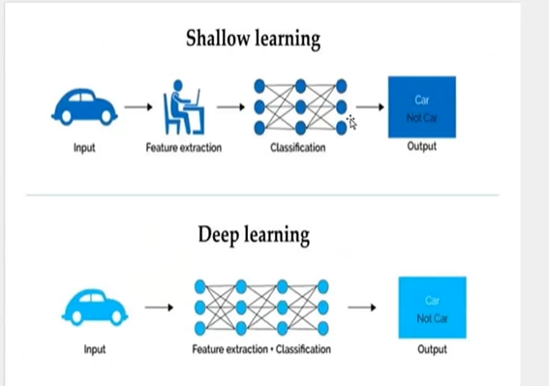

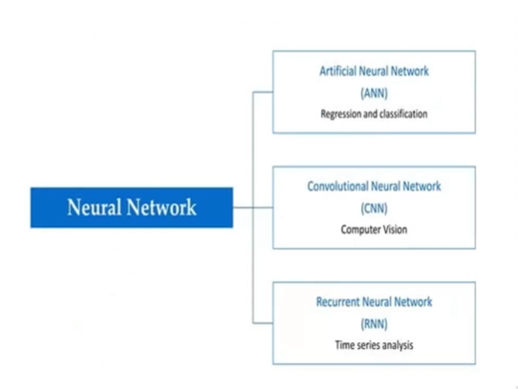

* **KNN**

K-nearest neighbors (KNN) is a type of supervised learning algorithm used for both regression and classification. KNN tries to predict the correct class for the test data by calculating the distance between the test data and all the training points. Then select the K number of points which is closest to the test data. The KNN algorithm calculates the probability of the test data belonging to the classes of ‘K’ training data and class holds the highest probability will be selected. In the case of regression, the value is the mean of the ‘K’ selected training points.

